Install apache tomcat on ec2
q. bash script to install apache tomcat.
Check if java is installed
Check if tomcat is installed
If not then script should install abd start the service
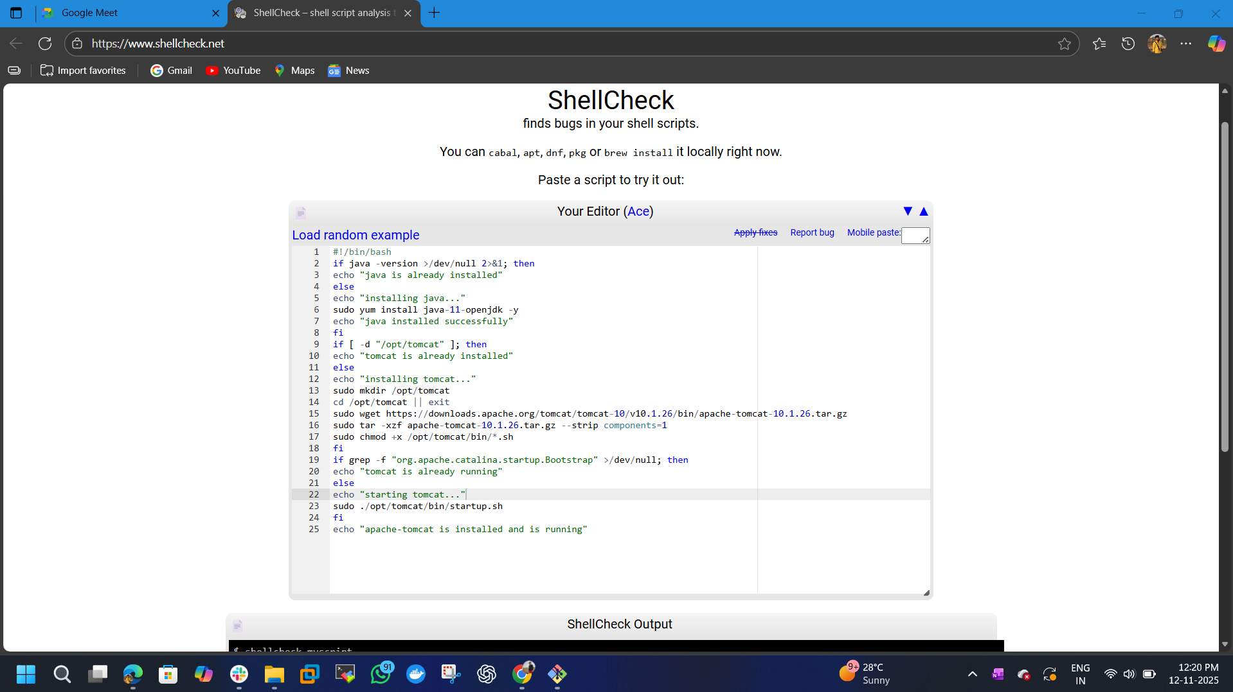

vi wmc-install-tomcat.bash

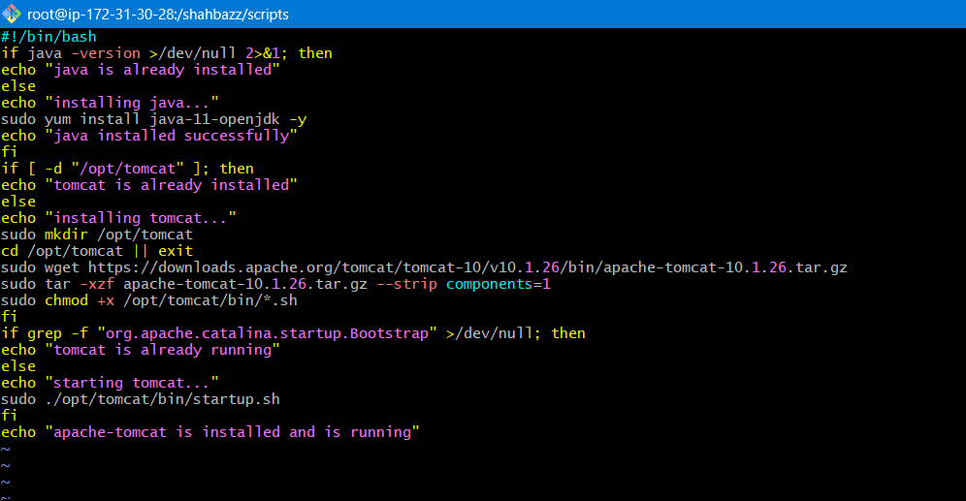

After allowing permissions to the file
chmod 755 wmc-install-tomcat.bash
./wmc-install-tomcat.bash
